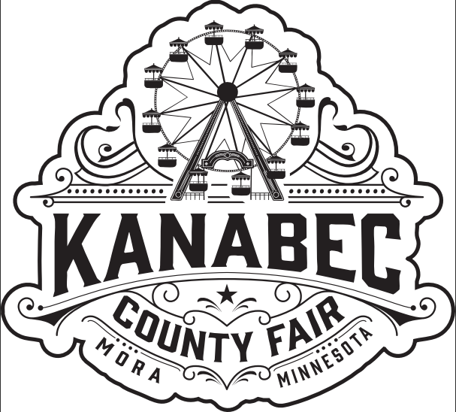
Hold
Harmless
Agreement

BY AND BETWEEN THE KANABEC COUNTY AGRICULTURAL SOCIETY AND ITS
COMMERCIAL VENDORS AND PARTICIPANTS

Date: ___________________________

Name of Event: Kanabec County Fair Event Dates: July 22nd - July 26th, 2026
_________________________________ (“Vendor”) and its undersigned participants shall
indemnify, save, hold harmless, and defend the Kanabec County Agricultural Society (“Owner”), for any loss, illness, injury, death, or damage to persons or property which at any time any be suffered or sustained by the Vendor, its participants, or by any person whosoever may at any time be using, occupying, or visiting the Kanabec County Fairgrounds (“Premises”), or be in, on or about the Premises, whether such loss, illness, injury, death or damage shall be caused by or in any way result from or arise out of any act, omission, negligence or intentional misconduct of the Vendor or of any participant, occupant, visitor, or user of any portion of the Premises or shall result from or be caused by any other matter or thing whether of the same kind as or of a different kind than the matters or things above set forth, and the Vendor shall indemnify the Owner against all claims, liability, loss, or damage whatsoever on account of any such loss, illness, injury, death, or damage, including Owner’s reasonable attorney’s fees.

Vendor Authorized Signature: _________________________________
Printed Name: ______________________________________
Participant Signature: __________________________ Name: _______________________
Participant Signature: __________________________ Name: _______________________
Participant Signature: __________________________ Name: _______________________

