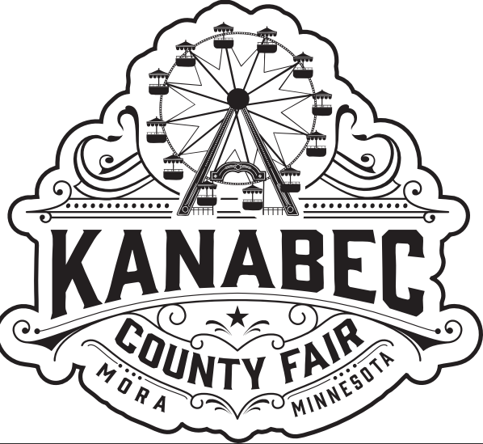
Kanabec County
Fair - Indoor
Space Rental

Thank you for your interest in a booth at the Kanabec County Fair. Returning vendors receive priority first and any remaining booths are subsequently made available to new vendors.
Event Dates: July 22nd through July 26th, 2026.
Set-up: Tuesday, July 21st from 11am - 6pm or Wednesday from 8:00am – Noon. There will be a grandstand event (Redneck Races at 7:00 pm, Beer Garden at 4:00pm, Event Center will be having a barn dance starting at 6:00pm, Carnival will open at 4:00pm and 4-H will be doing different events as well throughout the day).

Booth Details-
Booths are in the Commercial Building
Booths are approximately 7’x10’ or 8’x8’
Electricity is available in some locations
Tables & Chairs are not provided
ST-19 is required for all vendors
All vendors are responsible for the collection of sales tax on taxable items. All vendors are required to fill out an ST-19 even if products are not being sold.
Commercial Building is open from 11am-10pm Thursday through Saturday and 10am-4pm on Sunday.
The building will not open until Noon on Saturday due to the parade being held at 10am on Saturday morning so vendors can participate in the parade.

Details:
ALL vehicles must be moved out of the vendor areas during fair hours and parked in the parking lot by 11:00am each day, except on Wednesdays when they need to be removed by 4:00pm. If a vendor needs to bring supplies in during fair hours, they can contact the fair office, and we will assist with bringing them in via a golf cart. This is a requirement that our insurance company requires.

No Subletting or Transferring: Exhibitors are not allowed to sublet or transfer their space to another vendor.

Cost:
$125 per 7’x10’ or 8’x8’
$225 per 7’x20’ or 8’x16’

Payment Details:
We will confirm your registration once we have received your payment and vendor package, with no exceptions.
Please send checks and registration forms to the following address:
Kanabec County Agricultural Society
PO Box 395
Mora, MN 55051
Attn: Vendors
Please make checks payable to the Kanabec County Agricultural Society.
To secure your spot and gain vendor approval, you need to finish every necessary step first.
Packet needs to include the following:
Vendor Information page
ST-19
Hold Harmless Agreement
Certificate of Insurance & Food License (food vendors)
Payment in full

Registrations are due by May 15th, 2026, from last year’s vendors to hold your space. After the 15th we will open vendor space for the public.

Additional Information:
*It is not necessary for you to always remain in your booth. You may have an information booth,
but we ask that if it is all possible, please staff daily between 11:00am and 10:00pm.
* Kanabec County Agricultural Society reserves the right to deny space to any vendor or ask a
vendor to remove any offensive item from their booth.
*All campaigning must be done from a booth or within 10 feet of space directly in front of the
booth. Campaigning or handing out election material while walking the fairgrounds is
prohibited.
*Vendors shall keep their area neat and clean and notify fair office of any issues that are noticed.
*Vendors may not give weapons of any kind (guns, knives, cigarette lighters, etc.) as prizes or
winnings, unless the entrant is participating in a pre-approved raffle and the prize is not
awarded on fairgrounds.
*All items in vendor space should remain family friendly. Should an item be deemed by the fair
board as unsuitable for exhibition, the vendor will be asked to remove it from their display.
Failure to remove the item will result in vendor and their vendor exhibit removed from the
premises. Violating this rule will forfeit any fees paid and may prevent future exhibits.
*The KCAS fair board is not responsible for any damage to booths or loss by theft, fire, accident,
act of God, before, during or after fair hours.
*The KCAS Fair board shall be the final arbiter of any disputes with vendors. The Fair Office
shall provide information regarding the dispute and final decision shall be made by at least two
Fair Board Directors.

Kanabec County Agricultural Society is not responsible for lost or damaged items. Kanabec County Agricultural Society reserves the right to deny space to any vendor or ask a vendor to remove any offensive item from their booth.

We look forward to seeing you at the 2026 Kanabec County Fair.

Thank you,
Vendor Committee

