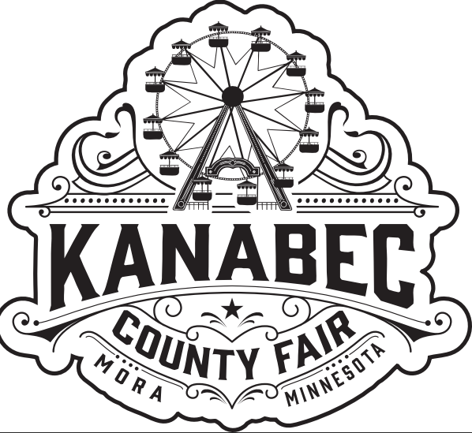
Kanabec County
Fair - Outdoor
Space Rental

Thank you for your interest in a booth at the Kanabec County Fair. Returning vendors receive priority first and any remaining booths are subsequently made available to new vendors.
Event Dates: July 22 through July 26th, 2026.
Set-up: Tuesday, July 21st from 11am - 6pm or Wednesday from 8:00am – Noon. There will be a grandstand event (Redneck Races at 7:00 pm, Beer Garden at 4:00pm, Event Center will be having a barn dance starting at 6:00pm, Carnival will open at 4:00pm and 4-H will be doing different events as well throughout the day). Fair will open at 4:00 pm on Wednesday, July 22, 2026

Details:
Spaces are in various locations throughout the fair.
All vendors must provide ST-19 forms.
Permitted generators must operate with minimal noise. Generators creating too much noise are not allowed, so you must replace your generator if it is excessively loud.
ALL vehicles must be moved out of the vendor areas and parked in the parking lot by 11:00am each day, except on Wednesdays when they need to be removed by 3:00pm. If a vendor needs to bring supplies in during fair hours, they can contact the fair office, and we will assist with bringing them in via a golf cart. This is a requirement that our insurance company requires. If a vehicle is required to stay in during fair hours it CAN NOT be moved and vendors will be charged accordingly for the space, they are using.

Cost:
Outside Vendors: $125.00 for 10 x10 (includes electricity if available)
$225.00 for 10 x 20 (includes electricity if available)

Payment Details:
We will confirm your registration once we have received your payment and vendor package, with no exceptions.
Please send checks and registration forms to the following address:
Kanabec County Agricultural Society
PO Box 395
Mora, MN 55051
Attn: Vendors
Please make checks payable to the Kanabec County Agricultural Society.

To secure your spot and gain vendor approval, you need to finish every necessary step first.
Packet needs to include the following:
Vendor Information page
ST-19
Hold Harmless Agreement
Payment in full

Registrations are due by May 15th, 2026, from last year’s vendors to hold your space. After the 15th we will open vendor space for the public.

Additional Information:
It is not necessary for you to always remain in your booth. You may have an information booth, but we ask that if it is all possible, please staff daily between 11:00am and 10:00pm.

Kanabec County Agricultural Society is not responsible for lost or damaged items. Kanabec County Agricultural Society reserves the right to deny space to any vendor or ask a vendor to remove any offensive item from their booth.

We look forward to seeing you at the 2026 Kanabec County Fair.

Thank you,
Vendor Committee

